Statistics Lecture 6.3: The Standard Normal Distribution. Using z-score, Standard Score

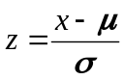

Example
A population of men has a mean weight of 172 lbs and a standard deviation of 29 lbs.
Find the probability that a randomly selected man will have a weight of less than 174 lbs.
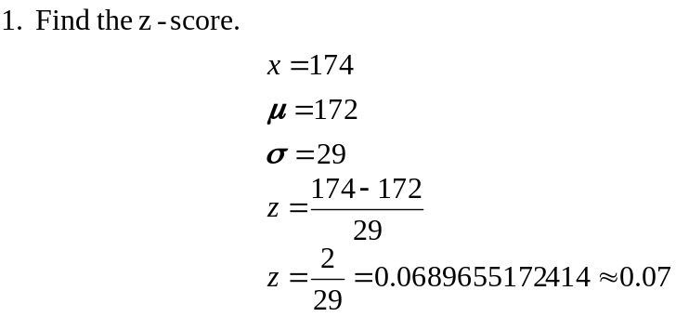

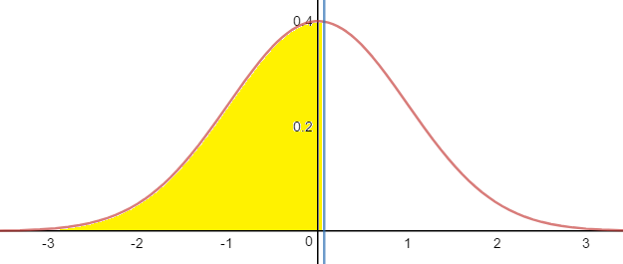

The probability of randomly selecting a man that will have a weight of less than 174 lbs.
is 52.79 %

Example
IQ is normally distribution with a mean of 100 and a standard deviation of 15.
What percentage of people have an IQ between 85 and 125?
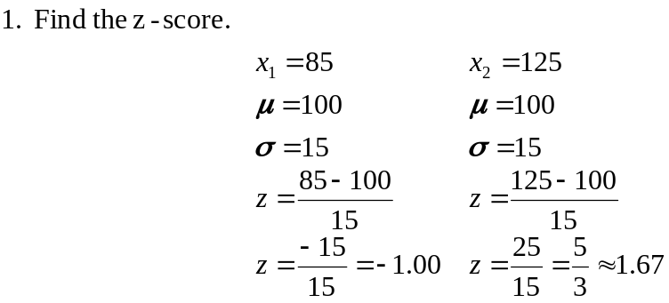

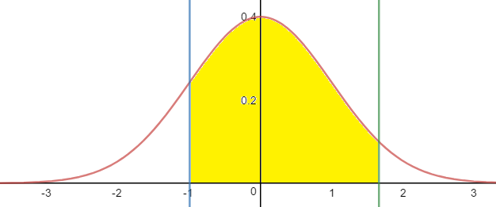
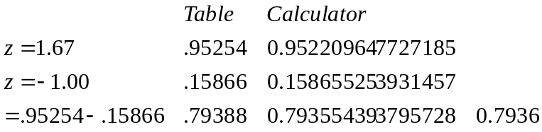

The percentage of people who have an IQ between 85 and 125 is 79.39%
Using Calculator is 79.36%

Key points
- Z-score is a distance from the mean.
- Area is a probability.
- Z-scores can be negative
- Area cannot be negative
We can find data values from z-scores.
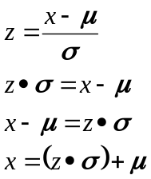

Picture
Find z-score
Solve for x

Example
A population of men has a mean weight of 172 lbs and a standard deviation of 29 lbs.
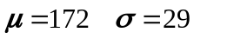
What weight separates the lightest 99.5% from the heaviest .5%?

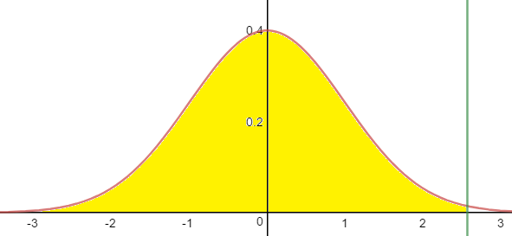
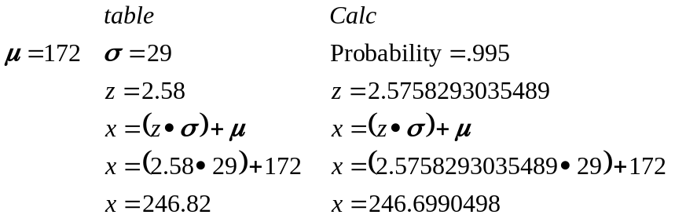

The weight separates the lightest 99.5% from the heaviest .5% is 246.8 lbs by table or 246.7 lbs using a calculator

Example
Grip reach for women is normally distributed.
The mean grip reach is 27 inches and a standard deviation of 1.3 inches.

Find the Grip reach that represents the longest 95% of women?

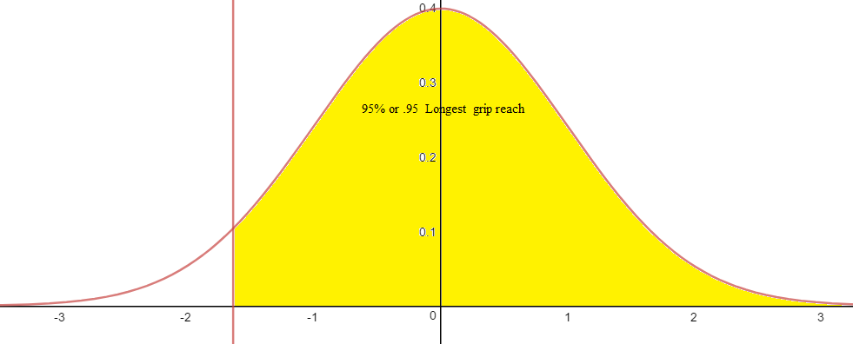

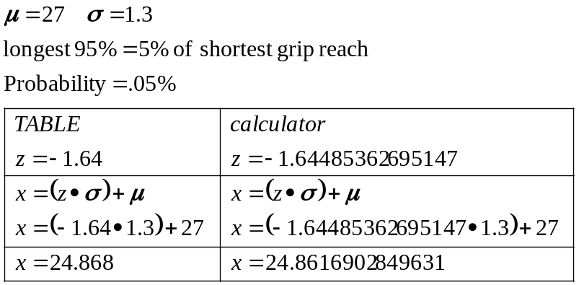
The Grip reach that represents the longest 95% of women is 24.86 inches.

